US Wind Mariners Briefing – June 16, 2022

Big news! US Wind recently received from the Bureau of Ocean Energy Management (BOEM), an agency within the U.S. Department of the Interior, a Notice of Intent to Prepare an Environmental Impact Statement on our Construction and Operations Plan (COP). See: https://uswindinc.com/wp-content/uploads/2022/06/us-wind-cop-fact-sheet.pdf
Indian River Bay Geophysical Survey Operations are complete!
The R/Vs Yeti, Almar, and WAM-V have completed high resolution geophysical survey operations within Indian River Bay, Delaware. US Wind thanks all mariners for their cooperation during these survey activities.

Looking Ahead
US Wind is planning to conduct benthic sampling within Indian River Bay from the R/V Almar in late July/early August 2022. After Labor Day 2022, US Wind anticipates conducting geotechnical investigations along the very near shore of the Delaware coast and within Indian River Bay.

US Wind Mariners Briefings can be found on our website at https://uswindinc.com/mariners/ or requested from Benjamin Cooper, US Wind’s Director of Marine Affairs (b.cooper@uswindinc.com). You may also wish to contact US Wind’s Fisheries Liaison Officers for fisheries specific information (Wolfgang Rain: 206-427-6553; wrain@searisksolutions.com and Ron Larsen: 570-242-5023; ronlarsen@searisksolutions.com).

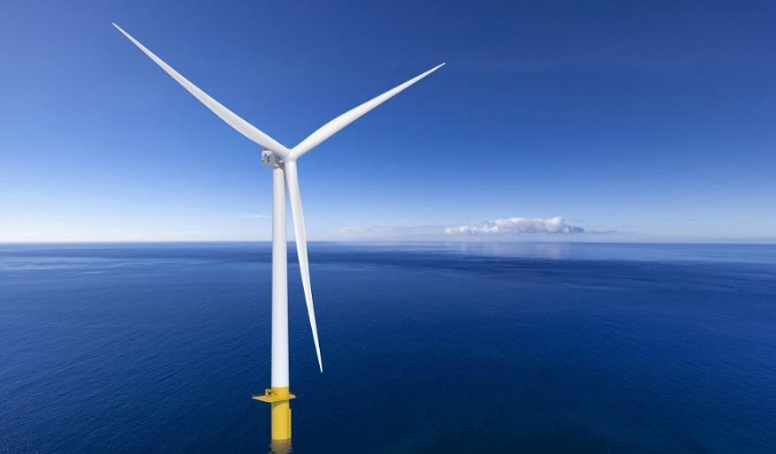

In 2014, US Wind acquired a federal Lease area off the coast of Maryland, which has the potential to generate approximately 2,000 MW in offshore wind power. In 2017, Maryland approved the company’s ~300 MW MarWin project, and in December 2021, the state approved the 808 MW Momentum Wind project. For more information, please visit our website: https://uswindinc.com.

