US Wind Mariners Briefing – May 24, 2022
Nearshore Geophysical Survey Operations are Complete!
The R/V Westerly has completed nearshore geophysical survey operations off the Atlantic coast of Delaware. This completes an extensive campaign to provide geophysical survey information for the Lease area and potential export cable corridors in the Atlantic. US Wind thanks all mariners for their cooperation during these survey activities.

Indian River Bay Geophysical Survey Operations
US Wind began conducting geophysical surveys with three vessels (R/Vs Yeti, Almar, and WAM-V) within Indian River Bay, Delaware, on May 9, 2022, which will continue for approximately eight (8) weeks. The vessels may tow survey equipment up to 100 feet behind the vessels. Trained Protected Species Observers (PSOs) will be used to ensure avoidance of any marine mammals and protected species. The survey vessel crews can be contacted via VHF-FM channels 13 and 16. US Wind’s fisheries liaison officers can be contacted at the phone numbers below for coordination with recreational and commercial fishing activity.

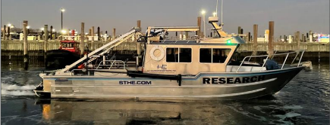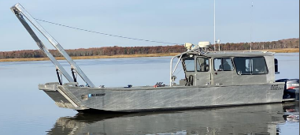
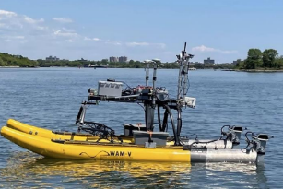
R/V Almar
R/V Yeti

R/V WAM-V

Looking Ahead
After Labor Day 2022, US Wind anticipates conducting geotechnical investigations along the very near shore of the Delaware coast and within Indian River Bay.

US Wind Mariners Briefings can be found on our website at https://uswindinc.com/mariners/ or requested from Benjamin Cooper, US Wind’s Director of Marine Affairs (b.cooper@uswindinc.com). You may also wish to contact US Wind’s Fisheries Liaison Officers for fisheries specific information (Wolfgang Rain: 206-427-6553; wrain@searisksolutions.com and Ron Larsen: 570-242-5023; ronlarsen@searisksolutions.com).

In 2014, US Wind acquired a federal Lease area off the coast of Maryland, which has the potential to generate approximately 2,000 MW in offshore wind power. In 2017, Maryland approved the company’s ~300 MW MarWin project, and in December 2021, the state approved the 808 MW Momentum Wind project. For more information, please visit our website: https://uswindinc.com.

