**US Wind[1] Mariners Briefing – May 3, 2022**

Near Shore Geophysical Survey Activity

The **R/V Westerly** has been conducting nearshore geophysical survey operations along the potential Export Cable Corridors within 3 nautical miles of the Delaware shoreline since April 3, 2022 and will continue to do so until mid-May, weather dependent. The **R/V Westerly** is accompanied by the **Ocean City Girl**, which carries Protected Species Observers and an Offshore Fisheries Liaison to support survey operations. Local scout vessels are also being used to identify fishing gear to ensure avoidance. US Wind has worked with stakeholders to reduce the area being surveyed to the areas outlined on the chartlet below. The remaining survey activity area is the 2.5NM by 3NM area identified on the chartlet.

US Wind will continue to communicate with local fishermen to coordinate our survey operations. The **R/V Westerly** requests a 250 yard closest point of approach from passing vessels and will monitor VHF-FM channels 13 and 16 for safe passing arrangements.



**R/V Westerly – 50 ft LOA; Call Sign: WDF7918**

Looking Ahead:

US Wind will begin conducting geophysical surveys with three vessels (**R/Vs Yeti**, **Almar 31**, and **WAM-V 8**) within Indian River Bay on **May 9, 2022,** lasting approximately 6 weeks. After Labor Day, US Wind anticipates conducting geotechnical investigations along the very near shore of the Delaware coast and within Indian River Bay.

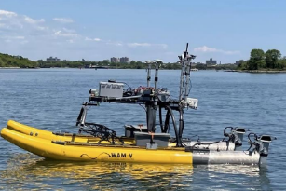

**WAM-V 8**

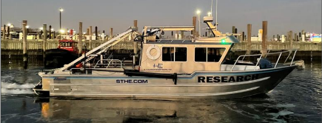

**R/V Yeti**

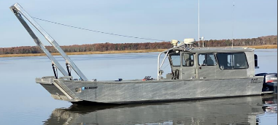

**Almar 31**

US Wind Mariners Briefings can be found on the US Wind website at <https://uswindinc.com/mariners/> or requested from Benjamin Cooper, US Wind’s Director of Marine Affairs ([b.cooper@uswindinc.com](mailto:b.cooper@uswindinc.com)). You may also wish to contact US Wind’s Fisheries Liaison Officers for fisheries specific information (Wolfgang Rain: 206-427-6553; [wrain@searisksolutions.com](mailto:wrain@searisksolutions.com) and Ron Larsen: 570-242-5023; [ronlarsen@searisksolutions.com](mailto:ronlarsen@searisksolutions.com)) or the Offshore Fisheries Liaison ([OFL6@Offshorewfs.com](mailto:OFL6@Offshorewfs.com)): 401-871-0557.

1. In 2014, US Wind acquired a federal Lease area off the coast of Maryland, which has the potential to generate approximately 2,000 MW in offshore wind power. In 2017, Maryland approved the company’s ~300 MW **MarWin** project, and in December 2021, the state approved the 808 MW **Momentum Wind** project. For more information, please visit our website: <https://uswindinc.com>.