**US Wind[1] Mariners Briefing – September 3, 2022**

Upcoming survey activity

US Wind will conduct a fall geotechnical survey campaign in fixed locations along the Atlantic coast of Delaware and inside Indian River Bay from approximately **September 10, 2022** to approximately **November 30,**  **2022**. Mariners are advised to use caution when transiting near the survey vessels and are requested to give a wide berth and slow bell. The vessels will monitor channels 13 and 16 VHF-FM for passing arrangements.

Inside Indian River Bay (daylight only operations):

**R/V CANDU** with support vessel **RAIDER**: September 12, 2022 to approximately September 30, 2022.

**R/V SMOKEY** with support vessel **ANTHONY MILLER**: September 26, 2022 to approximately November 30, 2022.

|  |  |
| --- | --- |
| **Survey area boundaries:** | |
| 38°36'19.5"N | 75°04'43.0"W |
| 38°35'27.5"N | 75°03’44.7"W |
| 38°35'09.0"N | 75°05'43.8"W |
| 38°35'06.4"N | 75°14'31.1"W |
| 38°35'37.1"N | 75°14'34.2"W |

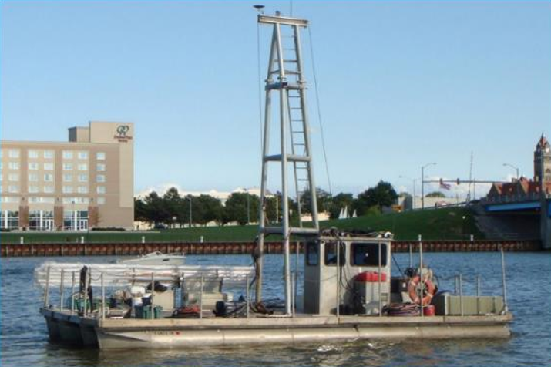 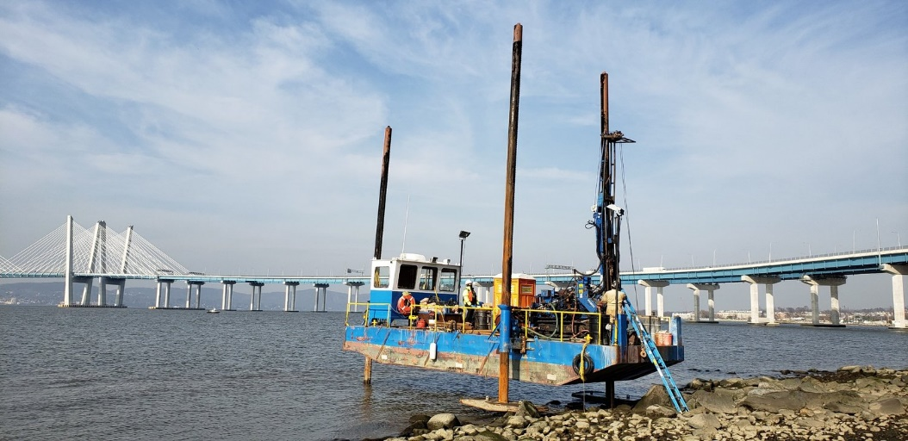

**R/V CANDU** **R/V SMOKEY**

Atlantic Ocean near the Delaware Atlantic shoreline (24 hour operations):

**R/V NORTHSTAR VOYAGER** with support vessel **INTERCEPTOR**: September 10, 2022 to approximately November 30, 2022.



**Lift Boat R/V NORTHSTAR VOYAGER; 91 ft LOA; Doc # 965698**

|  |  |
| --- | --- |
| **Northern survey area boundaries:** | |
| 38°41’01.1”N | 75°04’12.3”W |
| 38°40’04.4”N | 75°04’02.3”W |
| 38°39’18.5”N | 74°59’50.6”W |
| 38°40’56.4”N | 75°00’59.1”W |

|  |  |
| --- | --- |
| **Southern survey area boundaries** | |
| 38°35’41.5”N | 75°03’38.9”W |
| 38°35’40.0”N | 75°01’37.9”W |
| 38°33’49.2”N | 75°00’44.2”W |
| 38°35’16.8”N | 75°03’33.9”W |

US Wind Mariners Briefings can be found on our website at <https://uswindinc.com/mariners/> or requested from Benjamin Cooper, US Wind’s Director of Marine Affairs ([b.cooper@uswindinc.com](mailto:b.cooper@uswindinc.com)). You may also wish to contact US Wind’s Fisheries Liaison Officers for fisheries specific information (Wolfgang Rain: 206-427-6553; [wrain@searisksolutions.com](mailto:wrain@searisksolutions.com) and Ron Larsen: 570-242-5023; [ronlarsen@searisksolutions.com](mailto:ronlarsen@searisksolutions.com)).

1. In 2014, US Wind acquired a federal Lease area off the coast of Maryland, which has the potential to generate approximately 2,000 MW in offshore wind power. In 2017, Maryland approved the company’s ~300 MW **MarWin** project, and in December 2021, the state approved the 808 MW **Momentum Wind** project. For more information, please visit our website: <https://uswindinc.com>.